DINO_Update
Christina Fossum
2026-03-12

Models for UTDSP Intelimon Update

Contents:
- BB_PC_Cheatgrass: Model for Cheatgrass percent coverin Bighorn Basin
- BB_PC_NativeGrass: Model for native grass percent cover in Bighorn Basin
- BB_PC_Shrub: Model for shrub percent cover

1. BB_PC_Cheatgrass
model formula: lm1 <- lm(formula = train_pred$PC_BRTE ~ fuel0_3l1_kurt + shrubs_l1_kurt)
library(tidyverse)
## ── Attaching core tidyverse packages ──────────────────────── tidyverse 2.0.0 ──
## ✔ dplyr 1.1.4 ✔ readr 2.1.6
## ✔ forcats 1.0.1 ✔ stringr 1.6.0
## ✔ ggplot2 4.0.2 ✔ tibble 3.3.1
## ✔ lubridate 1.9.4 ✔ tidyr 1.3.2
## ✔ purrr 1.2.1
## ── Conflicts ────────────────────────────────────────── tidyverse_conflicts() ──
## ✖ dplyr::filter() masks stats::filter()
## ✖ dplyr::lag() masks stats::lag()
## ℹ Use the conflicted package (<http://conflicted.r-lib.org/>) to force all conflicts to become errors
library(leaps)
library(performance)
library(ggplot2)
# Load pred / vars data
pred <- read.csv("TLS/intelimon models/DINO_Update/DINO_pred.csv") %>% select(-1)
vars <- read.csv("TLS/intelimon models/DINO_Update/DINO_vars.csv")%>% select(-1)
# Create training/test data
set.seed(123)
sample_size <- floor(0.3* nrow(vars))
test_indices <- sample(seq_len(nrow(vars)), size = sample_size)
train_vars <- vars[-test_indices, ]
test_vars <- vars[test_indices, ]
train_pred <- pred[-test_indices, ]
test_pred <- pred[test_indices, ]
# Load model
lm1<- readRDS("TLS/intelimon models/DINO_Update/BB_PC_Cheatgrass.rda")
#look at the summary r2 values and RMSE & check model for colinearity
summary(lm1)
##
## Call:
## lm(formula = train_pred$PC_BRTE ~ fuel0_3l1_kurt + shrubs_l1_kurt)
##
## Residuals:
## Min 1Q Median 3Q Max
## -3.4927 -1.2041 0.0489 0.9652 5.5508
##
## Coefficients:
## Estimate Std. Error t value Pr(>|t|)
## (Intercept) 1.069664 0.828225 1.292 0.223004
## fuel0_3l1_kurt 0.058932 0.008222 7.167 1.83e-05 ***
## shrubs_l1_kurt 3.236604 0.602447 5.372 0.000226 ***
## ---
## Signif. codes: 0 '***' 0.001 '**' 0.01 '*' 0.05 '.' 0.1 ' ' 1
##
## Residual standard error: 2.542 on 11 degrees of freedom
## Multiple R-squared: 0.8925, Adjusted R-squared: 0.8729
## F-statistic: 45.66 on 2 and 11 DF, p-value: 4.709e-06
r2(lm1)
## # R2 for Linear Regression
## R2: 0.892
## adj. R2: 0.873
rmse(lm1)
## [1] 2.253642
check_model(lm1)
# Plot observed values vs. predicted
lm_out <- predict.lm(lm1, vars)
data<-data.frame(x=lm_out, y=pred$PC_BRTE)
ggplot(data,aes(x,y)) +
geom_point() +
geom_smooth(method='lm', se=FALSE,) +
theme_light() +
labs(x='Predicted Values', y='Observed Values', title='Percent Cover: Cheatgrass') +
theme(plot.title = element_text(hjust=0.5, size=20, face='bold')
)
## `geom_smooth()` using formula = 'y ~ x'
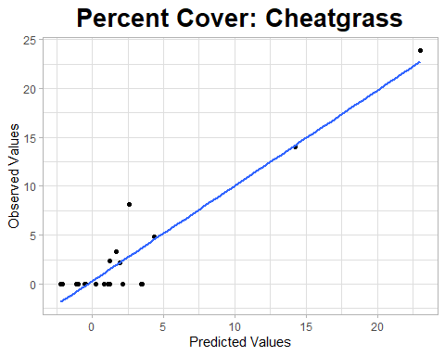
# use the model to predict test data
test_out<- predict.lm(lm1,test_vars)
errors<- test_out - test_pred$PC_BRTE
mae <- mean(abs(errors))
mse <- mean(errors^2)
rmse <- sqrt(mse)
rmse
## [1] 1.187271
# Plot test observed values vs. test predicted
data2<- data.frame(x=test_out, y=test_pred$PC_BRTE)
ggplot(data2,aes(x,y)) +
geom_point() +
geom_smooth(method='lm', se=FALSE,) +
theme_light() +
labs(x='Predicted Values', y='Observed Values', title='test') +
theme(plot.title = element_text(hjust=0.5, size=20, face='bold')
)
## `geom_smooth()` using formula = 'y ~ x'
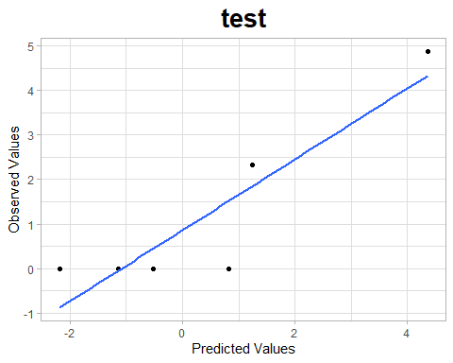

2. BB_PC_NativeGrass
model formula: lm1 <- lm(formula = train_pred$PC_NativeGrass ~ h_GC_kurt + fuel0_3l1_vari + hr0_10_l1_vari)
library(tidyverse)
library(leaps)
library(performance)
library(ggplot2)
# Load pred / vars data
pred <- read.csv("TLS/intelimon models/DINO_Update/DINO_pred.csv") %>% select(-1)
vars <- read.csv("TLS/intelimon models/DINO_Update/DINO_vars.csv")%>% select(-1)
# Create training/test data
set.seed(123)
sample_size <- floor(0.2* nrow(vars))
test_indices <- sample(seq_len(nrow(vars)), size = sample_size)
train_vars <- vars[-test_indices, ]
test_vars <- vars[test_indices, ]
train_pred <- pred[-test_indices, ]
test_pred <- pred[test_indices, ]
# Load model
lm1<- readRDS("TLS/intelimon models/DINO_Update/BB_PC_NativeGrass.rda")
#look at the summary r2 values and RMSE & check model for colinearity
summary(lm1)
##
## Call:
## lm(formula = train_pred$PC_NativeGrass ~ h_GC_kurt + fuel0_3l1_vari +
## hr0_10_l1_vari)
##
## Residuals:
## Min 1Q Median 3Q Max
## -14.7677 -2.3585 -0.5005 3.4524 8.3141
##
## Coefficients:
## Estimate Std. Error t value Pr(>|t|)
## (Intercept) 36.114330 1.818251 19.862 1.51e-10 ***
## h_GC_kurt -7.676000 1.564451 -4.907 0.000362 ***
## fuel0_3l1_vari 0.008689 0.003119 2.786 0.016478 *
## hr0_10_l1_vari -0.010882 0.001985 -5.481 0.000140 ***
## ---
## Signif. codes: 0 '***' 0.001 '**' 0.01 '*' 0.05 '.' 0.1 ' ' 1
##
## Residual standard error: 6.232 on 12 degrees of freedom
## Multiple R-squared: 0.8063, Adjusted R-squared: 0.7579
## F-statistic: 16.66 on 3 and 12 DF, p-value: 0.0001413
r2(lm1)
## # R2 for Linear Regression
## R2: 0.806
## adj. R2: 0.758
rmse(lm1)
## [1] 5.39744
check_model(lm1)
# Plot observed values vs. predicted
lm_out <- predict.lm(lm1, vars)
data<-data.frame(x=lm_out, y=pred$PC_NativeGrass)
ggplot(data,aes(x,y)) +
geom_point() +
geom_smooth(method='lm', se=FALSE,) +
theme_light() +
labs(x='Predicted Values', y='Observed Values', title='Percent Cover: Native Grass') +
theme(plot.title = element_text(hjust=0.5, size=20, face='bold')
)
## `geom_smooth()` using formula = 'y ~ x'
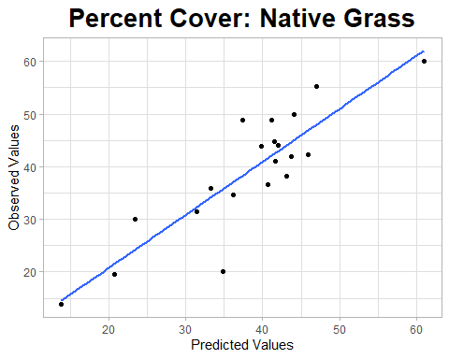
# use the model to predict test data
test_out<- predict.lm(lm1,test_vars)
errors<- test_out - test_pred$PC_NativeGrass
mae <- mean(abs(errors))
mse <- mean(errors^2)
rmse <- sqrt(mse)
rmse
## [1] 6.897144
# Plot test observed values vs. test predicted
data2<- data.frame(x=test_out, y=test_pred$PC_NativeGrass)
ggplot(data2,aes(x,y)) +
geom_point() +
geom_smooth(method='lm', se=FALSE,) +
theme_light() +
labs(x='Predicted Values', y='Observed Values', title='test') +
theme(plot.title = element_text(hjust=0.5, size=20, face='bold')
)
## `geom_smooth()` using formula = 'y ~ x'
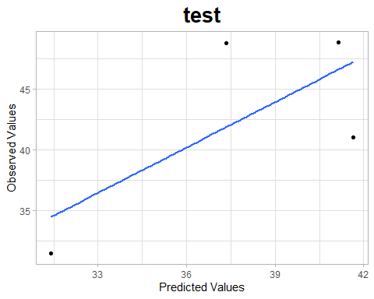

3. BB_PC_Shrub
model formula: lm1 <- lm(formula = train_pred$PC_Shrub ~h_OS_per + vox_l1_tgi + fine_l1_vari )
library(tidyverse)
library(leaps)
library(performance)
library(ggplot2)
# Load pred / vars data
pred <- read.csv("TLS/intelimon models/DINO_Update/DINO_pred.csv") %>% select(-1)
vars <- read.csv("TLS/intelimon models/DINO_Update/DINO_vars.csv")%>% select(-1)
# Create training/test data
set.seed(123)
sample_size <- floor(0.2* nrow(vars))
test_indices <- sample(seq_len(nrow(vars)), size = sample_size)
train_vars <- vars[-test_indices, ]
test_vars <- vars[test_indices, ]
train_pred <- pred[-test_indices, ]
test_pred <- pred[test_indices, ]
# Load model
lm1<- readRDS("TLS/intelimon models/DINO_Update/BB_PC_Shrub.rda")
#look at the summary r2 values and RMSE & check model for colinearity
summary(lm1)
##
## Call:
## lm(formula = train_pred$PC_Shrub ~ h_OS_per + vox_l1_tgi + fine_l1_vari)
##
## Residuals:
## Min 1Q Median 3Q Max
## -5.612 -3.560 -0.267 2.453 6.200
##
## Coefficients:
## Estimate Std. Error t value Pr(>|t|)
## (Intercept) 2.199e+01 1.260e+00 17.457 6.78e-10 ***
## h_OS_per -8.542e+03 2.961e+03 -2.885 0.01370 *
## vox_l1_tgi -3.638e+00 3.145e-01 -11.570 7.25e-08 ***
## fine_l1_vari 1.481e-02 4.494e-03 3.296 0.00639 **
## ---
## Signif. codes: 0 '***' 0.001 '**' 0.01 '*' 0.05 '.' 0.1 ' ' 1
##
## Residual standard error: 4.292 on 12 degrees of freedom
## Multiple R-squared: 0.9178, Adjusted R-squared: 0.8973
## F-statistic: 44.69 on 3 and 12 DF, p-value: 8.697e-07
r2(lm1)
## # R2 for Linear Regression
## R2: 0.918
## adj. R2: 0.897
rmse(lm1)
## [1] 3.716752
check_model(lm1)
# Plot observed values vs. predicted
lm_out <- predict.lm(lm1, vars)
data<-data.frame(x=lm_out, y=pred$PC_Shrub)
ggplot(data,aes(x,y)) +
geom_point() +
geom_smooth(method='lm', se=FALSE,) +
theme_light() +
labs(x='Predicted Values', y='Observed Values', title='Percent Cover: Native Grass') +
theme(plot.title = element_text(hjust=0.5, size=20, face='bold')
)
## `geom_smooth()` using formula = 'y ~ x'
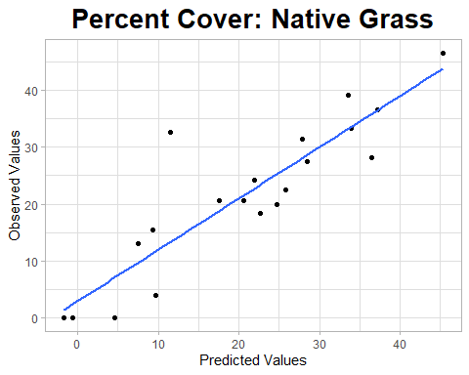
# use the model to predict test data
test_out<- predict.lm(lm1,test_vars)
errors<- test_out - test_pred$PC_Shrub
mae <- mean(abs(errors))
mse <- mean(errors^2)
rmse <- sqrt(mse)
rmse
## [1] 11.49719
# Plot test observed values vs. test predicted
data2<- data.frame(x=test_out, y=test_pred$PC_Shrub)
ggplot(data2,aes(x,y)) +
geom_point() +
geom_smooth(method='lm', se=FALSE,) +
theme_light() +
labs(x='Predicted Values', y='Observed Values', title='test') +
theme(plot.title = element_text(hjust=0.5, size=20, face='bold')
)
## `geom_smooth()` using formula = 'y ~ x'
